**MongoDb Task -1 Solution**

**Question:**

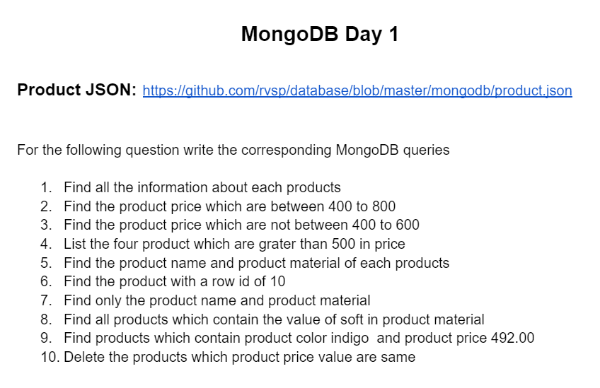

**Solution :**

Image of Uploaded mongodb database from Json:

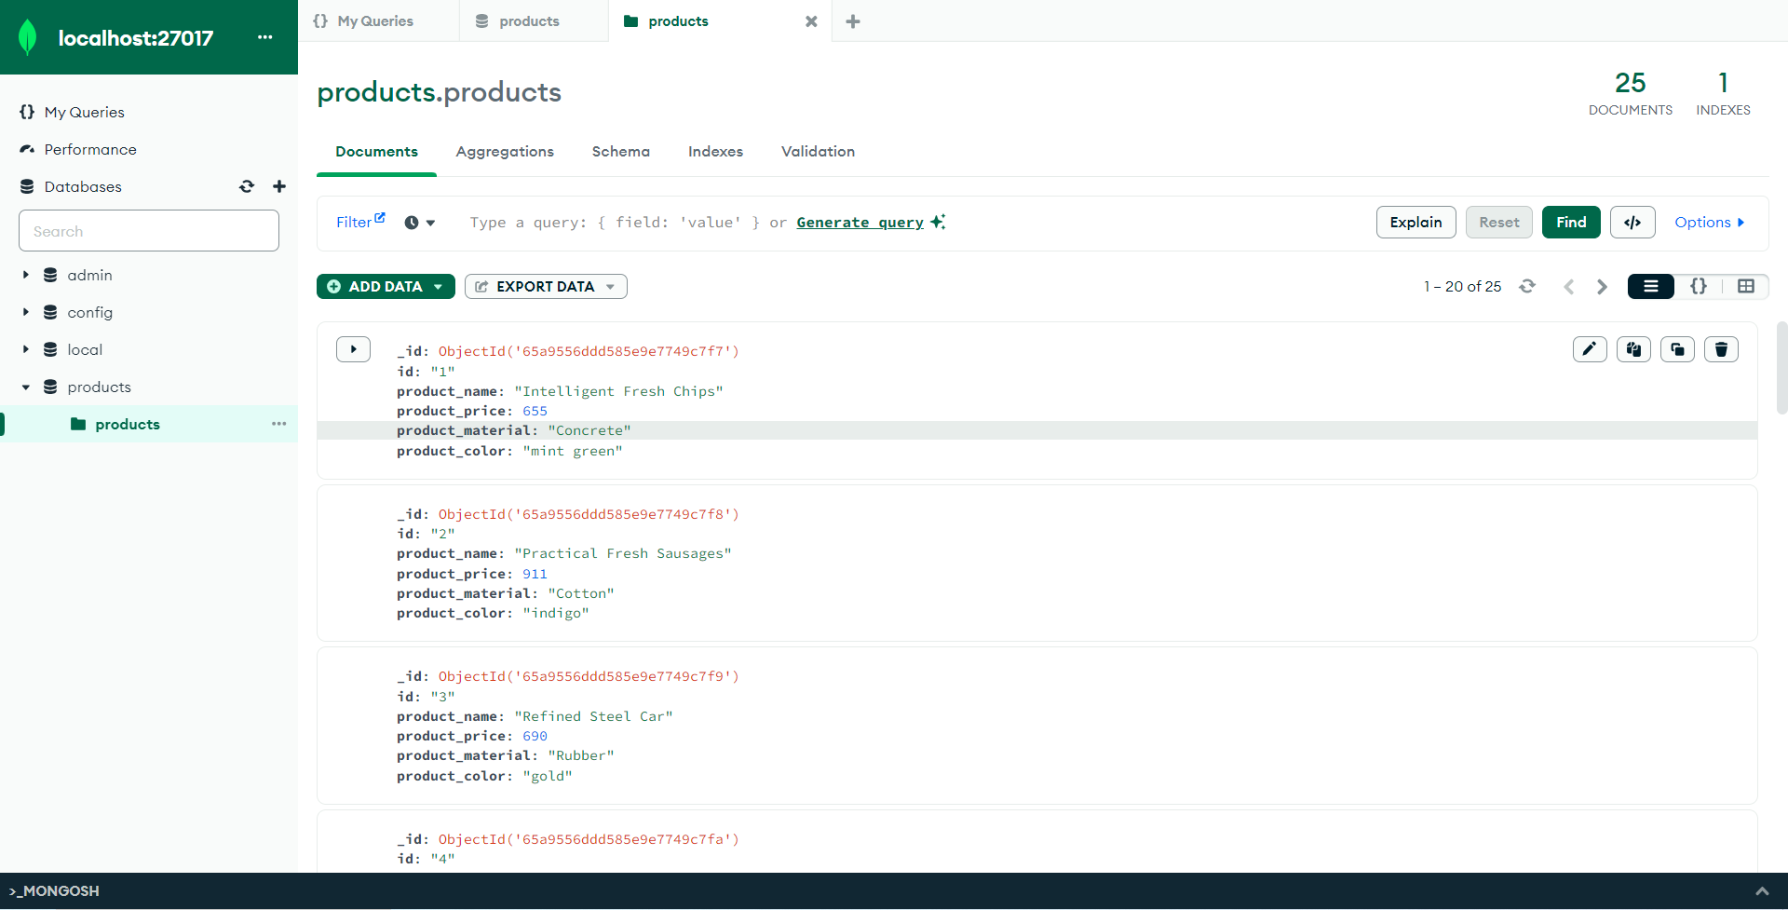

Answers for the queries:

1. db.products.find({})
2. db.products.find({“product_price”: {$gt:400,$lt:800’}})
3. db.products.find({“product_price”: {$not: {$gt:400,$lt:600’}}})
4. db.products.find({“product_price”: {$gt:500}}).limit(5)
5. db.products.find({},{“product_name”:1,”product_material”:1,”_id”:0})
6. db.products.findOne({“id”:”10”})
7. db.products.find({},{“product_name”:1,”product_material”:1,”_id”:0})
8. db.products.find({”product_material”:{$regex:/soft/i}})
9. db.products.find({“product_color”:”indigo”,”product_price”:492.00})
10. db.products.deleteMany({“product_price”:{$eq : 492.00}})